Identifying and Representing Functions
lesson
6-1

Practice and Problem Solving: A/B
Tell whether each relationship is a function.
1. 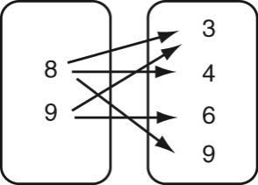 2. 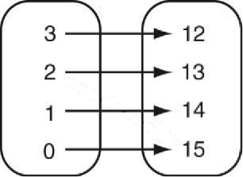 3. 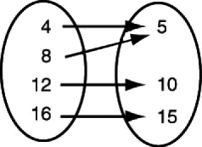

4. 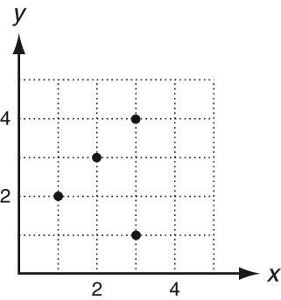 5. 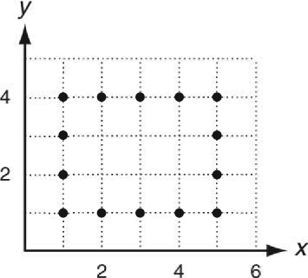 6. 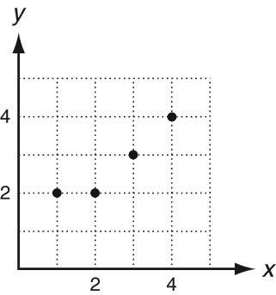

7. 8.
Input | 0 | 1 | 2 | 3
Output | 4 | 1 | 0 | 4

Input | 1 | 2 | 0 | 1 | 2
Output | 4 | 5 | 6 | 7 | 8

9. {(0, 0), (2, 4), (3, 6), (5, 5), (7, 6)} 10. {(0, 8), (1, 2), (3, 7), (5, 9), (3, 6)}

The graph shows the relationship between the hours
Rachel studied and the exam grades she earned.
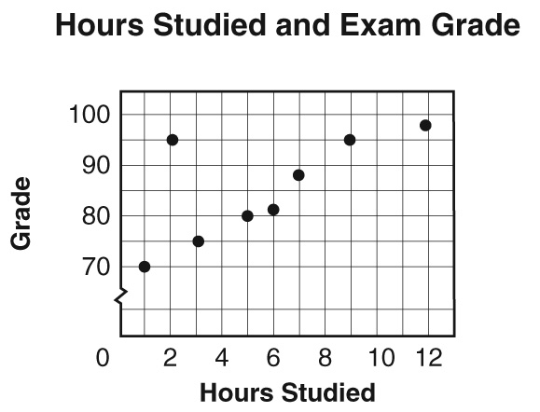
11. Is the relationship a function? Justify your answer. Use the
words “input” and “output” in your explanation, and connect
them to the context represented by the graph.
_____________________________________________________
_____________________________________________________
12. Rachel plans to study 2 hours for her next exam. How might
plotting her grade on the same graph change your answer
to Exercise 11? Explain your reasoning.
Identifying and Representing Functions
lesson
6-1

Reteach
A relation is a set of ordered pairs. {(1, 2), (3, 4), (5, 6)}
The input values are the first numbers in each pair. {(1, 2), (3, 4), (5, 6)}
The output values are the second numbers in each pair. {(1, 2), (3, 4), (5, 6)}
Circle each input value. Underline each output value.
1. {(1, 1), (2, 3), (3, 5)} 2. {(6, 2), (5, 3), (4, 8)}
A relation is a function when each input value is paired with only one output value.
The relation below is a function.  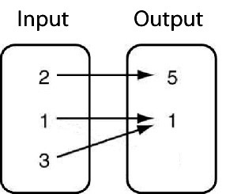  Input value 2 is paired with only one output, 5.  Input value 1 is paired with only one output, 1.  Input value 3 is paired with only one output, 1. | The relation below is not a function.  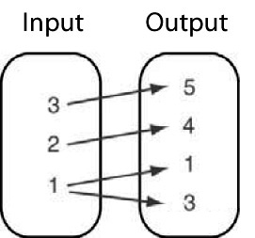  Input value 1 is paired with two outputs,  1 and 3.
Tell whether each relation is a function. Explain how you know.
3. {(1, 5), (3, 7), (6, 5), (9, 8} 4. {(1, 2), (1, 8), (3, 6), (4, 8)}

5. 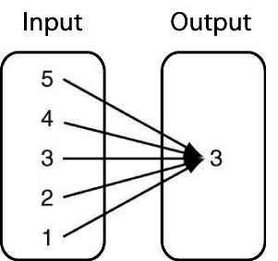 6. 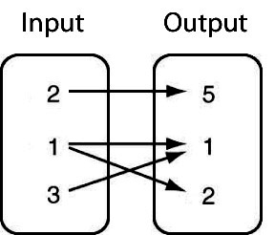

Describing Functions
LESSON
6-2

Practice and Problem Solving: A/B
Graph each equation. Tell whether the equation is linear or nonlinear.
1. y  3x 2. y  x²  1
Input, x | 1 | 0 | 1 | 2 | 4
Output, y

Input, x | 2 | 1 | 0 | 1 | 2
Output, y

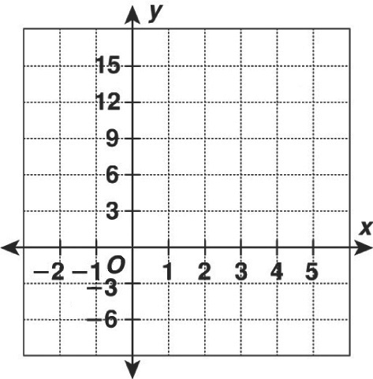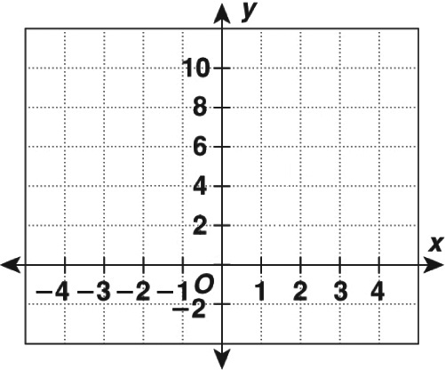

Tell whether each equation can be written in the form y  mx  b. Write yes or no. If yes, write the equation in the form y  mx  b.
3. y  8  x² 4. y  4  x 5. y  3  2x

The amount of water in a tank being filled is represented
by the equation y  20x, where y is the number of gallons
in the tank after x minutes.
6. Complete the table of values for this situation.
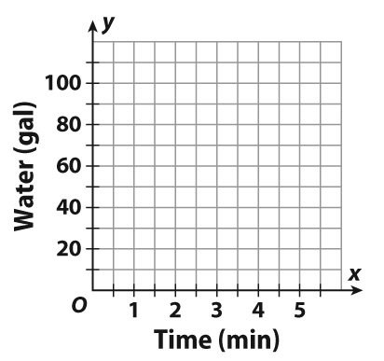
Time (min), x | 0 | 1 | 2 |  | 4
Water (gal), y |  |  |  | 60

7. Sketch a graph of the equation.
8. Use your graph to predict the amount of water in the tank
after 6 minutes.
________________________________________________________
9. Explain how you know whether relationship between x and y
is linear or nonlinear.

Describing Functions
lesson
6-2

Reteach
Graph y  x  2.
Step 1: Make a table of values.
Input, x | x  2 | Output, y | (x, y)
2 | 2  2  0 | 0 | (2, 0)
0 | 0  2  2 | 2 | (0, 2)
2 | 2  2  4 | 4 | (2, 4)
3 | 3  2  5 | 5 | (3, 5)

Step 2: Graph the ordered pairs, (x, y).
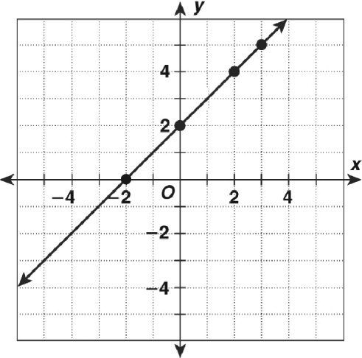
Step 3: Draw a line through the points.
Complete the table. Graph the function.  1. y  x  4 | 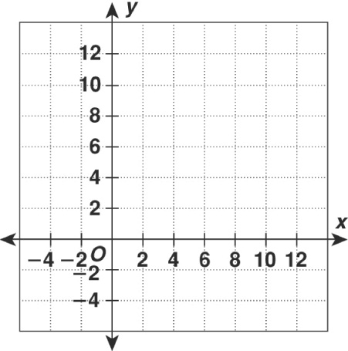
  Input, x | x  4 | Output, y | (x, y)
  2 | 2  4  ___ |  | (2, ___)
  0 | ___  4  ___
  2
  6
  8
A function is linear if:  • the graph is a line, and  • the equation can be written in the form y  mx  b.  A linear function is proportional if its graph passes  through the origin, (0, 0).  If the graph is not a line, then the function is nonlinear. | Linear: y  mx  b  y  4  3x y  3x  4  y  5x y  5x  0  Proportional: y  5x  0  5(0)  Not proportional: y  4  3x  0 ≠ 4  3(0)
Describe each function. Write linear, proportional, or nonlinear.
2. 3. y  2x  5 4.
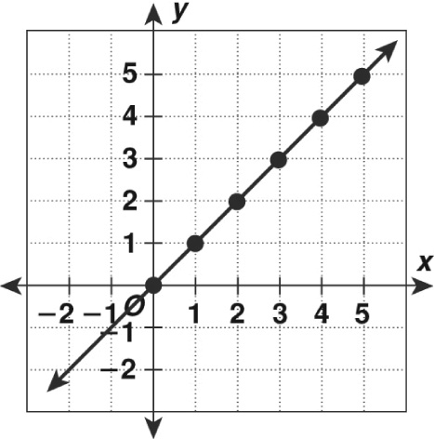
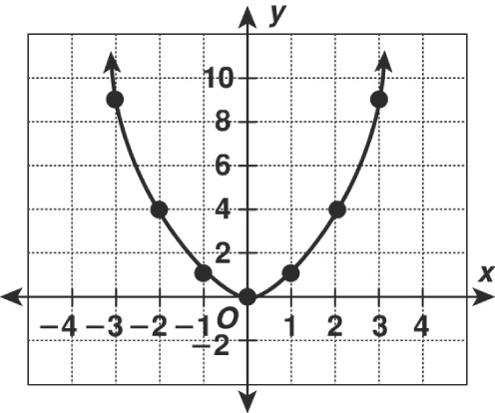

Comparing Functions
lesson
6-3

Reteach
Functions can be represented in many forms. You can identify the slope
and y-intercept from any format.
Representation | Slope | y-intercept
Equation written in  slope-intercept form:  y  mx  b | Value of m | Value of b
Table of values | Substitute any two ordered pairs into the slope formula.  m  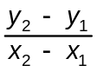 | Substitute the slope and one ordered pair (x, y) into the  slope-intercept formula.  y  mx  b  Solve for b.
Graph | Choose two points on the line. Find the ratio of vertical change to horizontal change. | Find the point where the line crosses the y-axis. You may need to extend the graph.

Find the slopes and y-intercepts of the linear functions f and g.
Then compare the graphs of the two functions.
1. f(x)  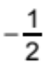x    2
x | 2 | 0 | 2 | 4 | 6
g(x) | 4 | 1 | 2 | 5 | 8

slope of f  _________________ slope of g  _________________
y-intercept of f: _________________ y-intercept of g: _________________

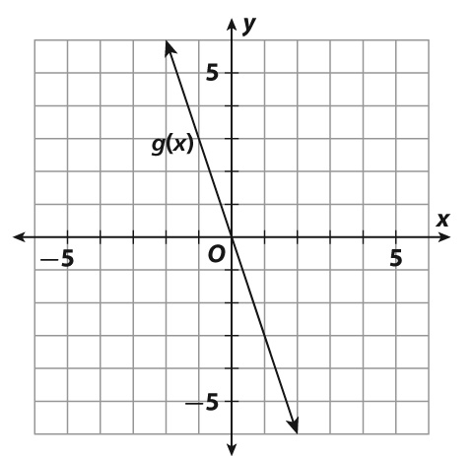
2. f(x)  6x  1
slope: | of f  _______ | of g  _______
y-intercept: | of f  _______  | of g  _______
______________________________________________
______________________________________________
______________________________________________

Analyzing Graphs
lesson
6-4

Practice and Problem Solving: A/B
Use the situation for 1–2.
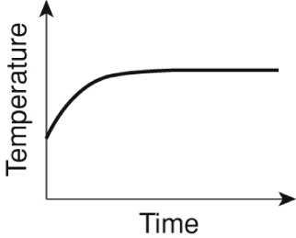
Dan is going to fix dinner. He turns on the oven. The graph
shows the temperature over time.
1. Why does the graph not start at zero?
_____________________________________
_____________________________________
2. What does it mean when the graph flattens out?

Tell which graph corresponds to each situation below.
Graph 1 Graph 2 Graph 3
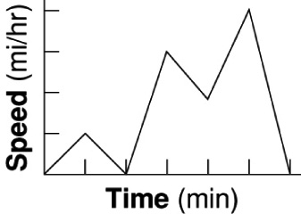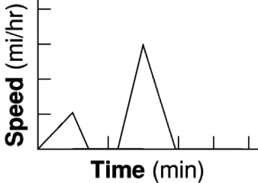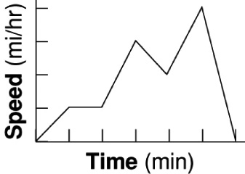
3. A car eases into traffic and then slows down and stops
at an intersection. Next it enters the highway and adjusts
speed to traffic until it exits and stops at home. ___________________________
4. A car eases into traffic, maintains speed for a short time.
Next it enters the highway and adjusts speed to traffic
until it exits and stops at home. ___________________________
5. Which graph did you not choose for Exercise 3 or Exercise 4?
Write a description that describes what happened in that graph.

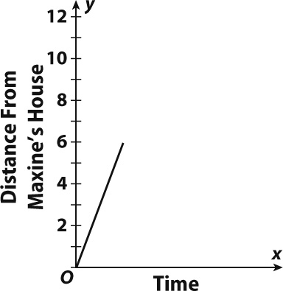
Use the graph at the right for 6–7.
6. Maxine bikes 6 miles from home. She then rests for a short time before biking 4 more miles. After a short rest, she bikes home. Complete the graph so it shows the distance Maxine is from home compared to the time.
7. Find the total number of miles Maxine biked.
_____________________________________

Analyzing Graphs
lesson
6-4

Reteach
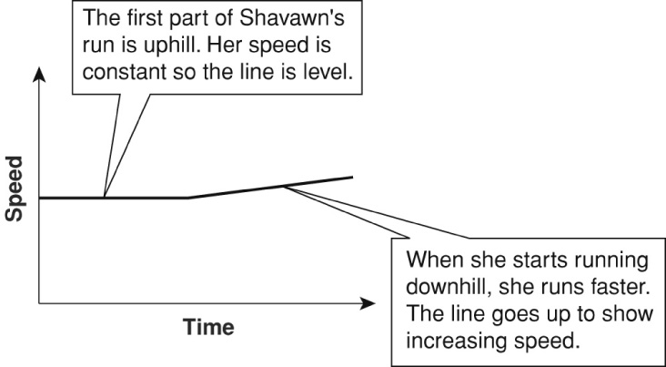
Graphs are often used to model situations. This graph shows Shavawn’s daily jogging routine. She jogs uphill at a steady speed. When she starts to run downhill, her speed increases.

You have a savings account in a bank. The graphs below show how the amount in your account changes. Describe what each graph shows.
1.  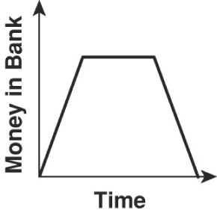 | 2.  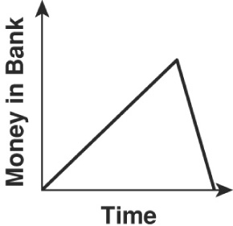
Complete the graph for each situation.
3. Mr. Wyatt drives for a while at a steady speed. A traffic jam slows him down. Then he resumes his normal speed.  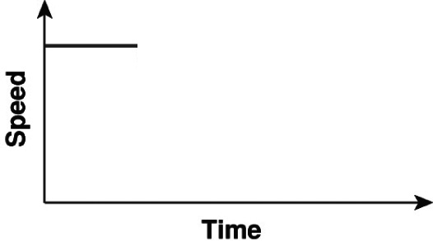 | 4. You are watching television. You turn down the volume during a commercial. You turn the volume back up after the commercial.  

