6th Grade Practice FSA Count Down
- Determine whether the following expressions are equivalent: $2s+13+15s and 17s+13$

2. Determine whether the following expressions are equivalent: $5\left(7h\right)and 35h$

3. Simplify: $5x+5y+x-y$

4. Simplify: $7x+12-2x+6$

5. Simplify: $8(8x+2y+12)$

6. Simplify: $11(4x-11)$

7. Evaluate for $y=3; 6y÷2+7$

8. The formula for the volume of a cube is${V=s}^{3}.$ If one side, $s$, of the cube is 6 cm, what is the volume in cubic centimeters?

9. A number divided by six is eight.

- The product of y and eight.

- Evaluate: $({\frac{1}{2})}^{5}$

- Evaluate: ${12}^{3}$
13. Determine whether the given value is a solution:
$$\frac{2}{9}h=4;h=18$$

- Determine whether the given value is a solution:
$$6x+1=67;x=6$$

- An ostrich egg weighs 1.6 pounds more than an emu egg. Write as an algebraic expression.

- Mike made 4 more bake sale signs than Steve. Write as an algebraic expression.

- Solve:
$$\frac{1}{2}x=18$$

- Solve:
$$h-13=49$$

- Write the following inequality as a word sentence. Then, list five possible solutions:
$$x<-3$$

- Write the following inequality as a word sentence. Then, graph the solution on a number line.
$$4≤x$$

- Use the equation to complete the table.
$$y=3x+1$$

x | y
0
2
4
6

- Write an equation to represent the relationship shown in the table.
x | y
0 | -3
3 | 0
6 | 3
9 | 6

Equation:____________________

. 22. Find the area of the given triangle:
Length: 13mm
Width: 12mm
. 23. Find the length of the given triangle:
Area: 120mm
Width: 60mm
24. Find the volume of the given rectangular prism :
Length: 4.5
Widht: 10
Height: 6
25. Find the Length of the given rectangular prism:
Length: 20
Widht: 30
Volume: 240
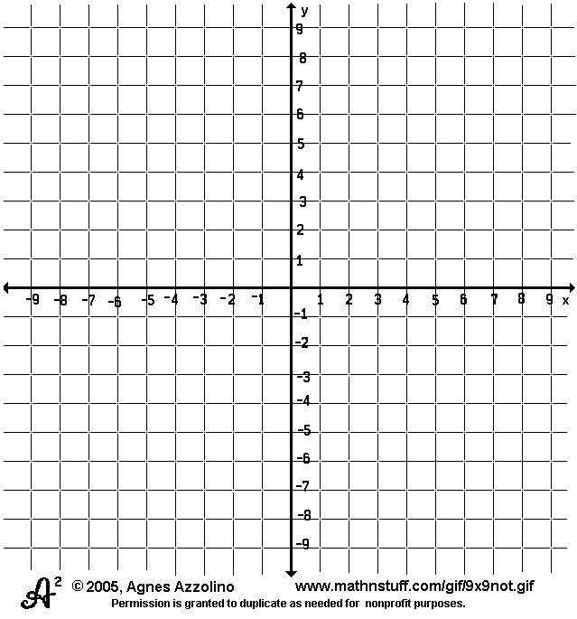
26. Draw a square in the third quadrant with one vertex at (-8, -6). Then, list the other vertices.
Ordered Pairs:
A: (-8,-6)
B: (______, _______)
C: (______, _______)
D: (______, _______)

27. Find the quotient:
$$12÷\frac{3}{4}$$
28. Find the product:
$$3\frac{1}{3}×\frac{1}{5}$$
29. Find the quotient
$\frac{300}{16}$
30. Find the difference:
$$23.54-14$$

31. Find the sum:
$$63.12+0.091$$

32. Find the quotient:
$$19.35÷3$$

33. Find the quotient:
$$9.66÷1.2$$

34. What integer would represent “a
Negative electric charge of six”?

35. Plot and label each point using the given coordinates.

- Point A: (6, -4)
- Point B: (0, -3)
- Point C: (-2, 0)
- Point D: (5, 1)

36. Find the opposite and absolute value for the given integer.
𝐼𝑛𝑡𝑒𝑔𝑒𝑟 = −2
𝑂𝑝𝑝𝑜𝑠𝑖𝑡𝑒 =
𝐴𝑏𝑠𝑜𝑙𝑢𝑡𝑒 𝑉𝑎𝑙𝑢𝑒 =

37. Write each ratio in simplest form:
$\frac{12}{18}=$ __________
$\frac{35}{40}=$ __________
$\frac{48}{60}=$ __________

X | 2 | 4
Y | 10 |  | 40 | 45
38. Directions: Complete each ratio table. Then, use the information to write each ratio in simplest form.
Ratio : ________

39. Ratio $\frac{1}{6}$
Decimal $__________$
Percent $__________$

40. A pair of pants is on sale for 25% off. If the original price was $40.00, what is the new sale price?

- Circle each statistical question. Mark an “X” next to each question that is not a statistical question.
What is Gavin’s pant size?
Did you ever enter into debate?
How old are my friends’ siblings?
How old are the students at the Belzer Middle School basketball game?
How long do the students at Sandy Beach Middle School ride on the bus each day?

- Give the mean, median, and mode for the following data set. Round to the nearest tenth, if necessary.
July 4th temperatures (degrees F):
89, 94, 96, 99, 96, 97, 95, 92
Mean: ____________
Median: ____________
Mode: ____________

